Practical 10
NAME: TASNEEM SADIKOT
PRN: 23070521162
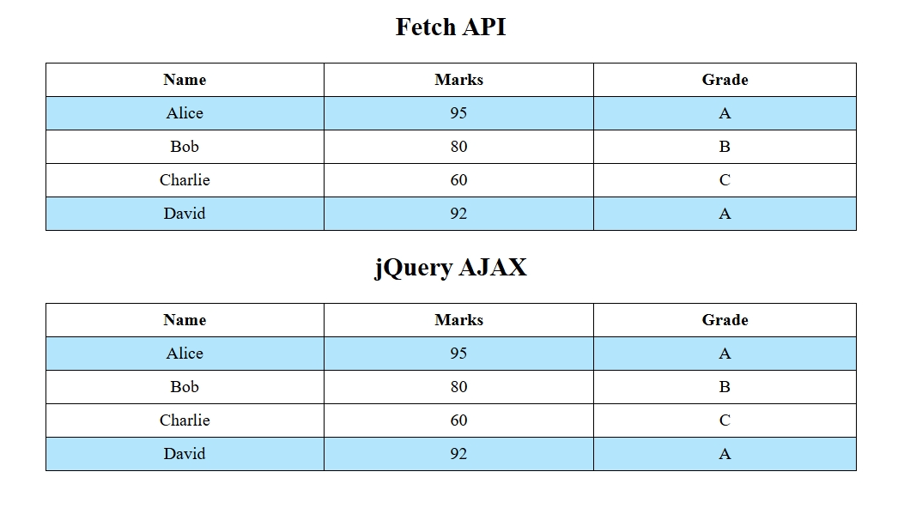
index.html
<!DOCTYPE html>
<html>
<head>
<title>Fetch vs jQuery AJAX</title>
<style>
table {
border: 1px solid #000;
border-collapse: collapse;
width: 50%;
margin: 10px auto;
}
th, td {
border: 1px solid #000;
padding: 6px;
text-align: center;
}
.highlight {
background: #b3e5fc;
}
h2, p {
text-align: center;
}

</style>
<script src="https://code.jquery.com/jquery-3.6.0.min.js"></script>
</head>
<body>
<h2>Fetch API</h2>
<p id="load1">Loading...</p>
<table id="fetch" style="display:none;">
<tr><th>Name</th><th>Marks</th><th>Grade</th></tr>
</table>

<h2>jQuery AJAX</h2>
<p id="load2">Loading...</p>
<table id="ajax" style="display:none;">
<tr><th>Name</th><th>Marks</th><th>Grade</th></tr>
</table>

<script src="script.js"></script>
</body>
</html>

script.js
const grade = m => m >= 90 ? "A" : m >= 75 ? "B" : "C";
// Fetch API
setTimeout(() => {
fetch("students.json")
.then(res => res.json())
.then(data => {
document.getElementById("load1").style.display = "none";
const t = document.getElementById("fetch");
t.style.display = "table";
data.forEach(s => {
const r = t.insertRow();
if (s.marks > 90) r.classList.add("highlight");
r.innerHTML = `<td>${s.name}</td><td>${s.marks}</td><td>${grade(s.marks)}</td>`;
});
});
}, 1500);
// jQuery AJAX
setTimeout(() => {
$.getJSON("students.json", data => {
$("#load2").hide();
$("#ajax").show();
data.forEach(s => {
const row = $("<tr>");
if (s.marks > 90) row.addClass("highlight");
row.append(`<td>${s.name}</td><td>${s.marks}</td><td>${grade(s.marks)}</td>`);
$("#ajax").append(row);
});
});
}, 1500);

students.json
[
{ "name": "Alice", "marks": 95 },
{ "name": "Bob", "marks": 80 },
{ "name": "Charlie", "marks": 60 },
{ "name": "David", "marks": 92 }
]

